
LIsTs

Part 1 - Fun with Indexing
1. Run this block of code in the python shell.

>>> a = ['she','sells','sea','shells','by','the','sea','shore']
>>> b = "selfish shellfish"
>>> c = [1, 1, 2, 3, 5, 8, 13]
Fill in the blanks below according to the example. Some may have more than one correct answer. Fill in the guess column before you try it on your computer.

List or String Indexing | Guess | Result
a[1] | ‘sells’ | 'sells'
b[3:4] | ‘f’ | ‘f’
c[5] | 8 | 8
c[:-2] | [1,1,2,3,5] | [1,1,2,3,5]
a[3] | ‘sea’ | 'sea'
2. Write True or False for each expression below. First try to guess, then check in the shell:

'by' in a True [1,2,5] in c False

'self' in b True 'sh' in c False

a[2] == a[6] True a[3] == b[8:13] False

3. Try out this code, which uses len(). Fill in the blanks with the results that would appear:
>>> dog = 'dalmatian'
>>> len(dog)
9
>>> dogs = [dog,'poodle','boxer']
>>> len(dogs)
3

Part 2 - Shelli

Run these two lines of code by typing them in the shell.
>>> one = [1,2,3,4]
>>> two = [7,6,5,4]
>>> three = ["y1", "friends", "fun"]

What gets printed to the screen after running the code in each box? (some boxes produce errors). First, you should guess, and then check the answer in the shell.

Input | Guess | Shell Output
>>> print (one + two) | [1,2,3,4,7,6,5,4] | [1,2,3,4,7,6,5,4]
>>> print (one[3]) | [4] | [4]
>>> one.remove(4)  >>> print(one) | [1,2,3] | [1,2,3]
>>> one.append(4)  >>> print(one) | [1,2,3,4] | [1,2,3,4]
>>> one.pop(1) | 2 | 2
>>> print(one) | [1,3,4] | [1,3,4]
>>> one.sort()  >>> print(one) | [1,3,4] | [1,3,4]

Part 3 - Fun with LIsTs
1.Read through the following codingbat example:
We will now being using codingbat to do some fun exercises. Here is an example of how to use codingbat:

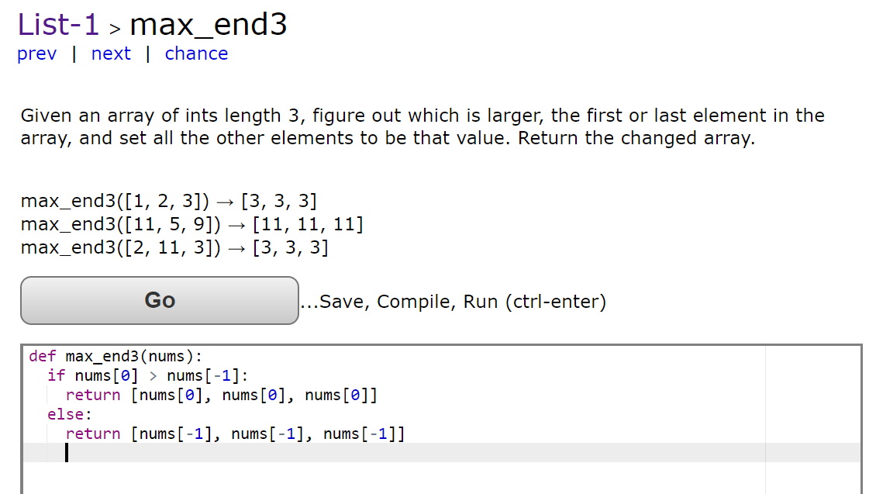

Or if that looks like gibberish (nonsense):

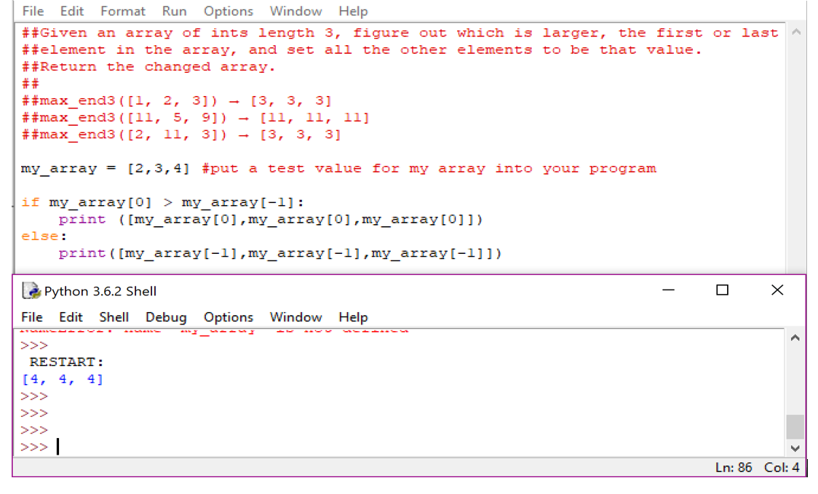
2. Complete the following codingbat exercises
List checking:
https://codingbat.com/prob/p236930
List matching:
https://codingbat.com/prob/p245813

Bonus One:
Still unsure about list operations, do this bonus: shelli on your own. Pick your own lists and try out the commands we learned on them. You can also try the following operations we didn't get to.

>>> one = [1,2,3,4]
>>> two = [7,6,5,4]

Input | Guess | Shell Output
>>> one.reverse()
>>> print(one)
>>> one.sort()
>>> print(one)
>>> one.remove(4)
>>> print(one)
>>> three = [3]
>>> four = three*3
>>> print(four)
>>> five = one.copy()
>>> one.sort()
>>> print(one)
>>> print(five)

You're turn! Come up with your own shelli.

Bonus Two :
Do more codingbat problems with lists!
- You can do the problems in whatever order you want!
Survey Time:

Super Fun Survey

